 |   International Scientific and Professional  Advisory Council  of the United Nations  Crime Prevention and Criminal  Justice Programme

International Conference on

MEASURING HUMAN TRAFFICKING
Complexities and Pitfalls

at the initiative of

International Scientific and Professional Advisory Council of the United Nations

Crime Prevention and Criminal Justice Programme/ ISPAC

Centro Nazionale di Prevenzione e Difesa Sociale/ CNPDS

in cooperation with
United Nations Office on Drugs and Crime/ UNODC, Vienna

Courmayeur Mont Blanc, Italy, 2 - 4 December 2005

Hotel Royal & Golf

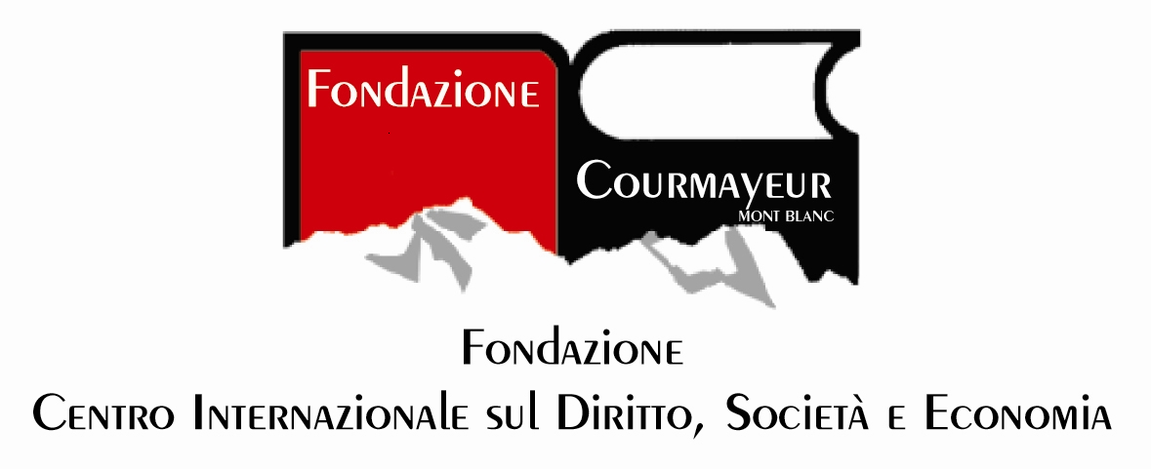

The trafficking of human beings is a major problem all over the world: this is also the case because there are serious difficulties related to the development of a comprehensive counter-strategy due to the scarcity, unreliability and non-comparability of existing data in the various countries. Despite certain improvements in recent years, the statistics on trafficking are still highly unsatisfactory all over the world.

There is an urgent need for a structured monitoring system of crime in this sector, which assesses and quantifies such illegal activity and provides the same set of quantitative and qualitative data for different countries of the world. A monitoring system which also considers the level of response and the compliance of the various countries to the requests set by the United Nations in their Protocol on trafficking in human beings. These data and information should be collected using standardised procedures and processed using the same methods so that they are as reliable as possible and can be effectively compared between countries. A body of information of this kind would yield profound knowledge on the problems and circumstances of people involved in the trade. The data could then be analysed with the overall goal of devising new solutions at both the national and supranational levels.

In the light of the above-mentioned issues, the Conference intends to convene public officials, researchers and practitioners in order to discuss the best methods to monitor and measure trafficking in human beings across the various nations of origin, transit and destination.

Firstly, definitional aspects are covered since it is not possible to collect information and measure a phenomenon across countries without having uniform definitions. Divergences in the field of criminal offences may also impair the collection and comparability of data on trafficking for sexual exploitation.

Secondly, the complex nature of trafficking, which makes it difficult to collect qualitative and quantitative information and to delimitate the phenomenon, is dealt with from different perspectives.

Thirdly, the Conference tries to answer the following central questions in order to improve the measurement of trafficking in human beings across countries: which are the state of the art statistics on trafficking in human beings? How is it possible to gather good statistics on trafficking in human beings and to assess them across countries? Is it possible to develop a collection plan for statistical information and analysis? Which indicators should be considered?

Finally, critical gaps and needs in the existing scenario are highlighted with a view to suggesting an effective monitoring system.
DRAFT PROGRAMME

Friday, 2 December 2005  3 p.m. | Opening Session  - Romano Blua, Mayor of Courmayeur  - Lodovico Passerin d’Entrèves, President of the Courmayeur Foundation  - Luciano Caveri, President of the Regional Government of the Aosta Valley Region  - Renato Ruggiero, Ambassador; President, Centro Nazionale di Prevenzione e Difesa Sociale/Ispac  - Michele Saponara, Under-Secretary of State, Ministry of the Interior of Italy  Keynote Address  - Antonio Maria Costa, Executive Director, United Nations Office on Drugs and Crime, Unodc
Session I:
Comparing definitions: implications for policies and research

- Defining trafficking in human beings at the UN level
Gino Polimeni, Director, United Nations Interregional Crime and Justice Research Institute-Unicri

- Uniform definitions for better measuring and for effective counter-measures
Kauko Aromaa, Director, European Institute for Crime Prevention and Control-Heuni

- The database of the Global Programme against trafficking in human beings of the Unodc
Kristiina Kangaspunta, Officer-in-Charge, Anti-human Trafficking Unit, United Nations Office on Drugs and Crime-Unodc

- Review of current initiatives/methods to measure human trafficking: strengths and weaknesses
Frank Laczko, Head, Research and Publications Division, International Organization for Migration-Iom, Geneva

Debate

Saturday, 3 December 2005  9.30 p.m. | Session II:  Why is it difficult to measure human trafficking: the complexity of the phenomenon  - Problems from the US perspective  Jay Albanese, Chief of the International Center, National Institute of Justice, Washington DC  - Problems from the EU perspective  Isabella Orfano, Expert Group on Trafficking in Human Beings of the EU Commission, Brussels  - Problems from the Dutch perspective  Monika Smit, Dutch National Rapporteur on Trafficking in Human Beings, The Hague  Problems from the NGOs’ perspective  - Review from Asia  Xin Ren, Ph.D, Criminal Justice Division, California State University, Sacramento
Saturday, 3 December 2005  3 p.m. | - Review from Eastern Europe  Miroslav Scheinost, Institute of Criminology and Social Prevention, Prague  - Review from Africa  Codou Bop, Consultant, Groupe de Recherche sur les Femmes et les Lois au Sénégal-Grefels , Dakar  Debate  Session III:  Measuring trafficking in human beings  - The transformation of qualitative facts into quantitative data  Grigoris Lazos, Associate Professor, Department of Criminology, Panteion University, Athens  - Review of official statistics on trafficking in human beings and their validity in the 25 EU Member States. From official statistics to estimates of the phenomenon  Andrea Di Nicola, Researcher, Faculty of Law, University of Trento; Coordinator of Transcrime (Joint Research Centre on Transnational Crime, University of Trento/Catholic University of Milan)  - Methods for measuring forced labour and irregular migration  Roger Plant, Head, Special action programme to combat forced labour, International Labour Organization-Ilo, Geneva
Sunday, 4 December 2005  9.30 p.m. | - Towards an EU template and collection plan for statistical information and analysis on missing and sexually exploited children and trafficking in human beings  Gert Vermeulen, Director, Institute for International Research on Crime Policy-Ircp, University of Ghent  - Measuring the non-measurable: towards the development of indicators for measuring human trafficking  Sonia Stefanizzi, professor of Sociology, University of Milan-Bicocca  Debate  - Summary and conclusions  Ernesto U. Savona, Professor, Catholic University, Milan; Director, Transcrime (Joint Research Centre on Transnational Crime, University of Trento/Catholic University of Milan)

Official languages: English, French and Italian with simultaneous interpretation

Coffee Breaks at 11.00 a.m. and 5 p.m.

Conference Secretariat:
Centro nazionale di prevenzione e difesa sociale
Palazzo Comunale delle Scienze Sociali
3, Piazza Castello - 20121 Milano MI
Phone: +39 02 86.46.07.14 - Fax : +39 02 72.00.84.31
E-mail: cnpds.ispac@cnpds.it - Home page: www.cnpds.it
Home page: www.ispac-italy.org

Conference Venue:
Hotel Royal & Golf
Via Roma, 87 – 11013 Courmayeur, Aosta, Italy
Tel. +39 0165 83.16.11– Fax: +39 0165 84.20.93
E-mail: royal.ricevimento@ventaglio.com

Milan, 4 November 2005

